Gas chromatogram

1. Study the following diagram along with parts names.

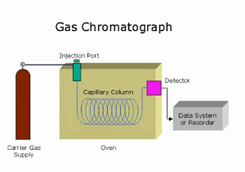

Learn diagram & the parts of a chromatogram

Use the following sites for having some points to note.

http://www.chem.ucla.edu/~bacher/General/30BL/gc/theory.html

http://www.explainthatstuff.com/chromatography.html

http://teaching.shu.ac.uk/hwb/chemistry/tutorials/chrom/gaschrm.htm

Why do substances become separated when they move through the column of gas chromatogram?

